COLLEGE CODE : 3105

COLLEGE NAME : DHANALAKSHMI SRINIVASAN COLLEGE OF ENGINEERING AND TECHNOLOGY.

DEPARTMENT : B.TECH INFORMATION TECHNOLOGY.

STUDENT NM-ID : 9bb6b241f18d4e79ec648e9c1bebf781

ROLL NO :310523205021

DATE :14-05-2025

Personalized Marketing and Customer Experience Using AI

SUBMITTED BY:

Team members name:

1. **V.Devadharshini**
2. **K.Balaji**
3. **S.Bhuvanesh**
4. **G.Bharathipriya**

**Phase 5 – Project Demonstration & Documentation**

**Title:** Personalized Marketing and Customer Experience Using AI

**Abstract:**

The Personalized Marketing and Customer Experience project aims to enhance customer engagement and conversion by leveraging artificial intelligence, machine learning, and behavioral analytics. In this final phase, the system integrates customer profiling, real-time recommendation engines, and sentiment analysis to deliver hyper-personalized interactions across digital platforms. This document outlines the final demonstration, technical documentation, performance evaluations, testing reports, and system architecture. Designed for scalability and privacy compliance, the project enhances both marketing outcomes and customer satisfaction.

**Index:**

|  |  |  |
| --- | --- | --- |
| S.NO | TOPIC | PAGENO |
| 1. | Project Demonstration | 3 |
| 2. | Project Documentation | 3 |
| 3. | Feedback And Final Adjustment | 4 |
| 4. | Final Project Report Submision | 5 |
| 5. | Project Handover And Future Works | 5 |

**1. Project Demonstration**

**Overview:**  
The project will be presented to stakeholders to highlight how AI transforms marketing into a personalized experience for each user, using data-driven insights and automation.

**Demonstration Details:**

* **User Journey Simulation:** Show how user profiles are dynamically built based on interactions and preferences.
* **Recommendation Engine:** Real-time product/service suggestions based on behavioral data.
* **Sentiment Analysis:** Monitor and analyze customer feedback (text, voice, or social media posts).
* **Campaign Performance Metrics:** Visual display of improved engagement rates, click-throughs, and conversions.
* **Data Privacy & Compliance:** Showcase GDPR compliance and secure handling of customer data.

**Outcome:**  
Demonstration proves system effectiveness in delivering relevant content, optimizing campaigns, and maintaining trust via data security.

**2. Project Documentation**

**Overview:**  
This section provides detailed technical and functional documentation.

**Documentation Sections:**

* **System Architecture:** Diagrams showcasing AI/ML pipelines, user interaction flows, and data collection modules.
* **Source Code Snapshots:** Explanation of modules for recommendation algorithms, API integrations, and data preprocessing.
* **User Guide:** Steps for marketers to create and deploy campaigns, and for customers to manage personalization settings.
* **Admin Guide:** Instructions on system updates, user behavior monitoring, and performance tracking.
* **Testing Reports:** Reports detailing algorithm accuracy, user feedback loop efficiency, and load testing results.

**Outcome:**  
Comprehensive documentation ensures ease of system maintenance, adaptation, and scaling.

**3. Feedback and Final Adjustments**

**Overview:**  
Feedback from mentors, stakeholders, and test users is collected and used to fine-tune the platform.

**Steps:**

* **Survey and Analytics:** Collect feedback via forms and usage data analytics.
* **Refinement:** Improve personalization algorithms, optimize UX/UI, and fine-tune campaign logic.
* **Final Testing:** Validate improvements with A/B testing and user behavior monitoring.

**Outcome:**  
System is fine-tuned for performance, relevance, and usability.

**4. Final Project Report Submission**

**Overview:**  
Summarizes the full project lifecycle and future impact.

**Report Sections:**

* **Executive Summary:** Highlights the project's goals, impact, and innovations.
* **Phase Breakdown:** From customer data acquisition to final user experience delivery.
* **Challenges & Solutions:** Addressed data sparsity, cold-start problems, and privacy concerns.
* **Outcomes:** Personalized marketing boosts engagement, satisfaction, and conversion rates.

**Outcome:**  
Project meets its objectives with clear potential for commercial deployment.

**5. Project Handover and Future Works**

**Overview:**  
Final phase focusing on continuity and growth.

**Handover Details:**

* **Next Steps:** Proposals for deeper AI integration, omnichannel experiences, and real-time customer feedback loops.
* **Documentation Pack:** Includes codebase, API docs, performance logs, and user training manuals.
* **Outcome:**  
  Project is ready for scale and future feature expansion.

**HTML & CSS CODING:**

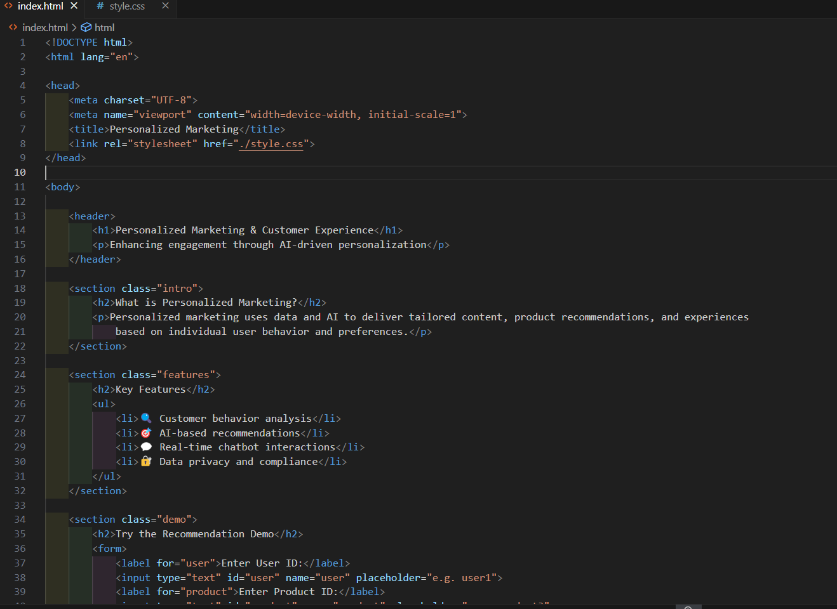

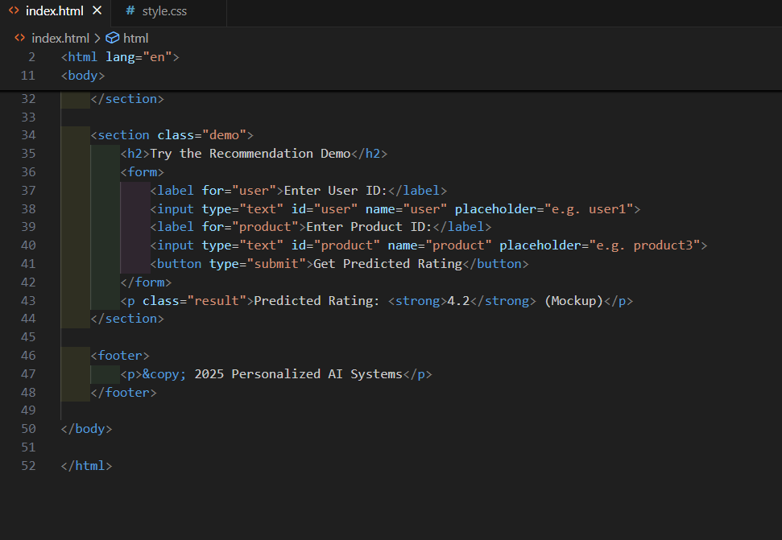

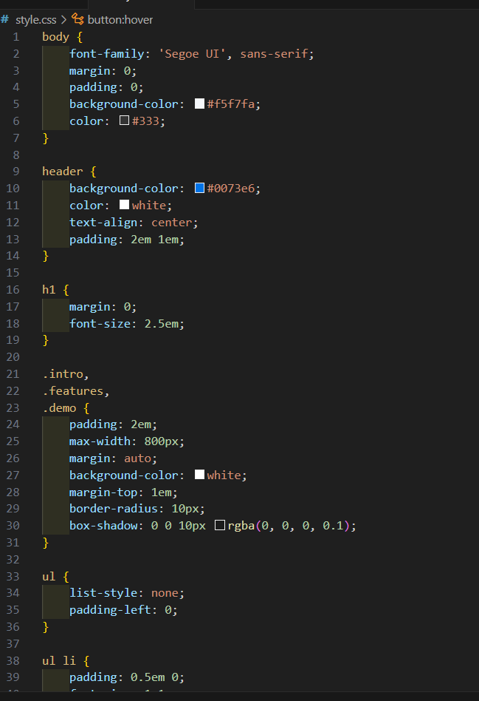

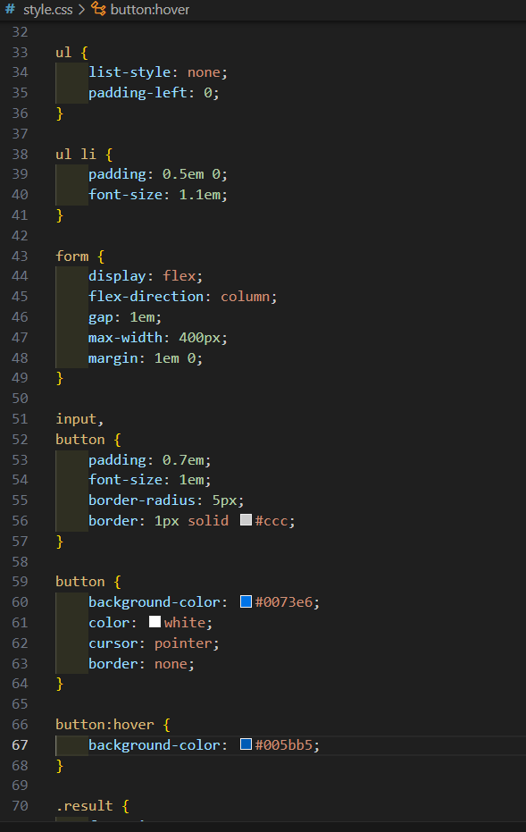

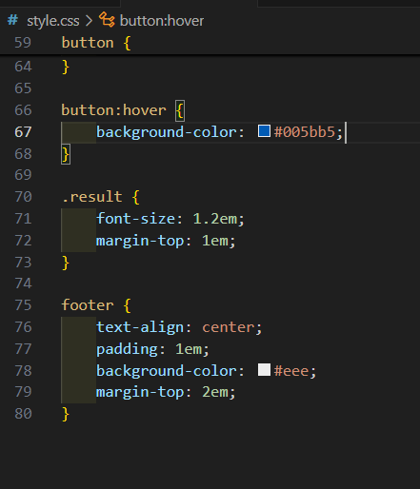

**PYTHON CODING:**

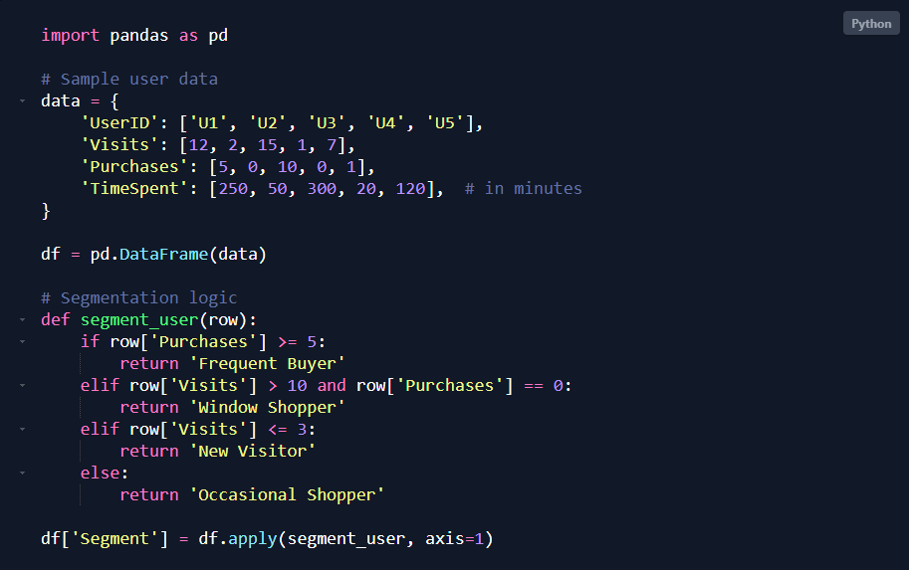

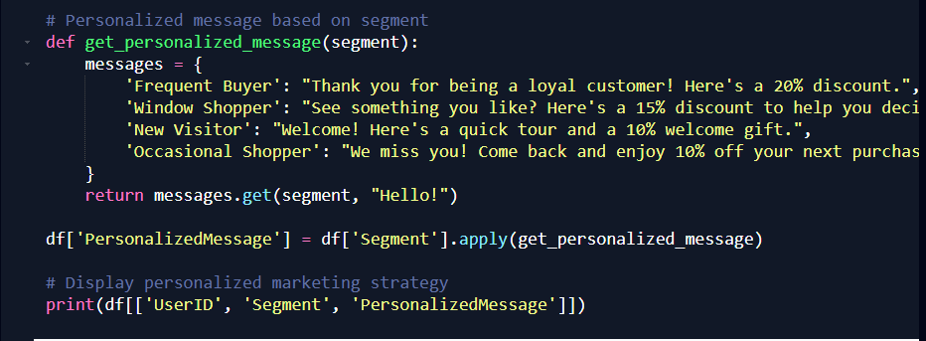

**BACK END OUTPUT:**

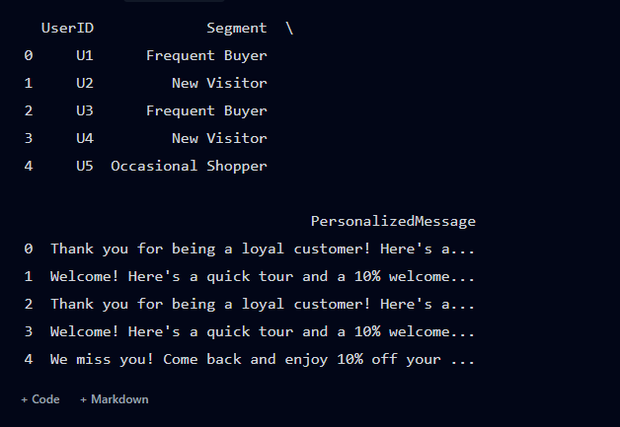

**FRONT END OUTPUT:**

